**MOBILE PHONE JAMMER**

by

D. Charan-17bec1208

T. Jayanth Kumar-17blc1030

K. Madhu Sekhar Raju-17bec1124

M. B. V. Sri Harsha-17bec1195

A project report submitted to

Prof. Lakshmi B

**SCHOOL OF ELECTRONICS ENGINEERING**

in partial fulfilment of the requirements for the course of

ECE-2002  
 ANALOG ELECTRONIC CIRCUITS

in

**B.Tech. ELECTRONICS AND COMMUNICATION ENGINEERING**



**Vellore Institute of Technology (VIT) CHENNAI**

**Vandalur – Kelambakkam Road**

**Chennai – 600127**

**OCTOBER-2018**

**BONAFIDE CERTIFICATE**

Certified that this project report entitled “**MOBILE PHONE JAMMER”** is a bonafide work of **D. CHARAN (17BEC1208), T. JAYANTH KUMAR (17BLC1030), K. MADHU SEKHAR (17BEC1124)** and **M. B. V. SRI HARSHA (17BEC1195)** who carried out the Project work under my supervision and guidance.

**Prof. Lakshmi B**

Associate Professor

School of Electronics Engineering (SENSE),

VIT University, Chennai

Chennai – 600 127.

|  |  |  |  |
| --- | --- | --- | --- |
| **SERIAL NO.** |  | **NAME** | **PAGE NO.** |
|  |  | ABSTRACT | 4 |
|  |  | ACKNOWLEDGEMENT | 5 |
|  |  |  |  |
| 1 |  | INTRODUCTION | 6 |
|  |  |  |  |
|  | 1.1 | OBJECTIVES AND GOALS | 6 |
|  | 1.2 | BENEFITS | 6 |
|  | 1.3 | FEATURES | 6 |
|  |  |  |  |
| 2 |  | DESIGN | 7-18 |
|  | 2.1 | BLOCK DIAGRAM | 7 |
|  | 2.2 | COMPONENTS EXPLANATION | 8-9 |
|  |  |  |  |
| 3 | WORKING | PRINCIPLE | 10-11 |
|  |  |  |  |
| 4 | CONCLUSION |  | 12 |
| 5 | REFERENCES |  | 12 |
|  |  |  |  |

**ABSTRACT**

The GSM mobile jammer is a device which transmits the signals to the same frequency. The jamming section is successful when the area of the mobile phone signal is disabled if the jammer is on. The first jamming device was developed and used by the military for communication purpose. Where the planed commanders use RF communication to control their power and also in enemy communications. Nowadays the mobile users are increasing day by day, hence the mobile phone jammer devices are becoming civilian by comparing with the electronic devices to disable the mobile signals in specific locations.

**ACKNOWLEDGEMENT**

We wish to express our sincere thanks and deep sense of gratitude to our project guide, **PROF. LAKSHMI.B,** Associate Professor, School of Electronics Engineering, for his consistent encouragement and valuable guidance offered to us in a pleasant manner throughout the course of the project work.

We are extremely grateful to **Prof. Sreedevi. V.T,** Dean of the School of Electronics Engineering, VIT Chennai, for extending the facilities of the School towards our project and for her unstinting support.

We express our thanks to our Programme Chair **Prof. MENAKA .R** and Co-Chair **Prof.Reena Monica.P** for their support throughout the course of this project.

We also take this opportunity to thank all the faculty of the School for their support and their wisdom imparted to us throughout the course.

We thank our parents, family, and friends for bearing with us throughout the course of our project and for the opportunity they provided us in undergoing this course in such a prestigious institution.

**1.INTRODUCTION**

* 1. **OBJECTIVES AND GOALS**

• Learn and apply the fundamentals of a Transistor.

• Investigate the application of components in a circuit.

• Learn how to simulate a circuit in LT spice.

• Learn how to interact with a circuit simulation in real-time and observe the output

* 1. **BENEFITS**

Cell phones are becoming more of an irritating tool than an item of connection. The widespread usage of tool is becoming irritating and dangerous shoulder to shoulder. Mobile phones are wrongly utilized by students in the exam room, they are utilized in the infirmaries which may be very irritating and dangerous for the ill people and those who have pace maker located in the heart. Mobile phones are more lately utilized by terrorists for organizing explosions in several locations at a time. Therefore by, the cell phone jammers are utilized to stop all such situations from becoming out of hand.

**1.3 APPLICATIONS**

* The Mobile jammers are used in the classrooms, and library to maintain silence
* It is used in the seminar halls and meeting rooms to avoid disturbances
* It is used in the hospitals
* The mobile jammers are used in the temples, churches, etc

**2 MOBILE PHONE JAMMER DESIGN**

**2.1 BLOCK DIAGRAM**

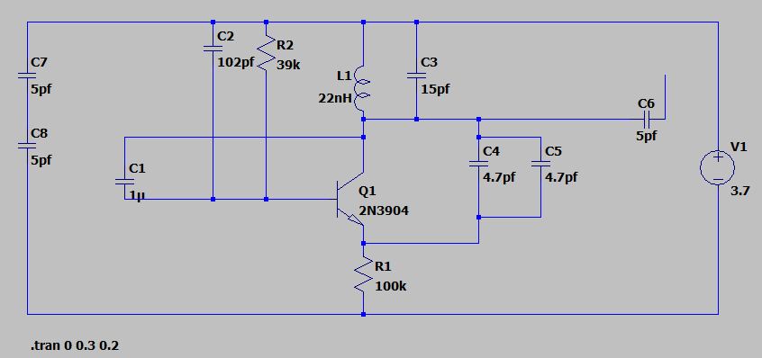

**Battery**

The following overview shows you the components as they really look and the schematic symbols as they are used in the circuit diagrams. A plug-in power supply unit, e.g., could be used instead of a battery. The battery as it really looks and as schematic symbol (B_Batterie.gif) Do not use alkaline batteries or rechargeable batteries, but only simple zinc-carbon batteries. The alkaline battery has a longer service life, but if there is a fault, e.g., a short circuit, it delivers (just like a rechargeable battery) very large currents up to more than 5 A. They can severely heat thin wires or even the battery itself. By contrast, the short circuit current of a zinc-carbon battery is usually smaller than 1 A. Thus sensitive components can already be destroyed, but there is no danger of fire.

**NPN transistors**

Transistors are components for amplifying small currents. The educational kit contains two silicon NPN transistors BF494. The terminals of the transistor are called emitter (E), base (B) and collector (C). The base terminal is in the middle. The emitter lies to the right if you look at the labelling and the terminals point downward.

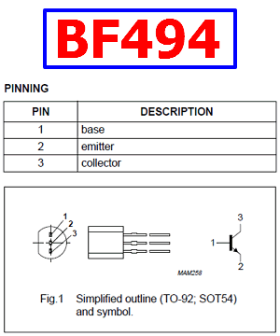

**Capacitors**

The capacitor is an important component in electronics. It consists of two metal surfaces and an insulation layer. If you apply electric voltage, between the capacitor plates an electric force field forms in which energy is stored. A capacitor with a large plate surface and a small distance between the plates has a large capacitance and thus stores a lot of charge with a given voltage. The capacitance of a capacitor is measured in farads (f).

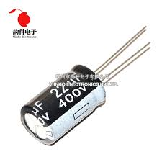

**Resistor**

A **resistor** is a [passive](https://en.wikipedia.org/wiki/Passivity_(engineering)" \o "Passivity (engineering)) [two-terminal](https://en.wikipedia.org/wiki/Terminal_(electronics)" \o "Terminal (electronics)) [electrical component](https://en.wikipedia.org/wiki/Electronic_component" \o "Electronic component) that implements [electrical resistance](https://en.wikipedia.org/wiki/Electrical_resistance" \o "Electrical resistance) as a circuit element. In electronic circuits, resistors are used to reduce current flow, adjust signal levels, to divide voltages, [bias](https://en.wikipedia.org/wiki/Biasing" \o "Biasing) active elements, and terminate [transmission lines](https://en.wikipedia.org/wiki/Transmission_line" \o "Transmission line), among other uses. High-power resistors that can dissipate many [watts](https://en.wikipedia.org/wiki/Watt" \o "Watt) of electrical power as heat, may be used as part of motor controls, in power distribution systems, or as test loads for [generators](https://en.wikipedia.org/wiki/Electric_generator" \o "Electric generator). Fixed resistors have resistances that only change slightly with temperature, time or operating voltage. Variable resistors can be used to adjust circuit elements (such as a volume control or a lamp dimmer), or as sensing devices for heat, light, humidity, force, or chemical activity.

Resistors are common elements of [electrical networks](https://en.wikipedia.org/wiki/Electrical_network" \o "Electrical network) and [electronic circuits](https://en.wikipedia.org/wiki/Electronic_circuit" \o "Electronic circuit) and are ubiquitous in [electronic equipment](https://en.wikipedia.org/wiki/Electronics" \o "Electronics). Practical resistors as discrete components can be composed of various compounds and forms. Resistors are also implemented within [integrated circuits](https://en.wikipedia.org/wiki/Integrated_circuits" \o "Integrated circuits).

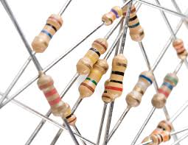

**3.WORKING PRINCIPLE**

As we can see that the transistor Q1, and the two capacitors C4 & C5 and also with one resistor can compose the RF amplifier. By using the tuned circuit the RF amplifier amplifies the signal and the amplification signal is given to the antenna with the help of the capacitor C6 this capacitor will remove the DC signal and permit the AC signal. If the transistor Q1 is in ON state, then the tuned circuit at the collector end will be tune ON and the tuned circuit consists of capacitor C1 & inductor L1 hence it act as an oscillator with zero resistance. This oscillator will produce the high frequency with minimum impair. Both the indicator & capacitor in the tuned circuit will oscillate the resonating frequency.

The operation of the tuned circuit is easy to learn & understandable. If the tuned circuit is ON then the voltage is stored by the capacitor according to the capacity and the electric energy is the main function of the capacitor. Once the capacitor is fully charged it will allow the charge to flow through an indicator. Basically the inductor is used to store the magnetic energy through this voltage across the capacitor it will get decreased automatically, at the same time total magnetic energy is stored in the inductor and the charge of the capacitor will be zero. The inductor of the magnitude will be decreased and the capacitor will be charged with the help of current in a reverse polarity manner. After some period of time capacitor is charged completely and the magnetic energy transversely the inductor will be zero. Once again, the capacitor will produce the charge to the inductor and becomes zero. After some time, interval the capacitor will be charged with the help of an inductor and the capacitor will become zero.

The internal resistance is generated hence the oscillation will be stopped. The supply of the RF amplifier is through the capacitor C5 to the collector terminal which is before C6 for gain signal to the tuned signal. For generating noise, the capacitors C2 and C3 are used for the frequency generated by the tuned circuit and these capacitors will produce the electronic pulses in random.

The cell phone Jammer works with the frequency of 450MHz if this frequency is hunk we need to generate the 450MHz frequency with same noise which is acted as a blocking signal because the receiver of the cell phone signal will not be able to understand the received signal. By this circuit we can able to block the cell phone signals.

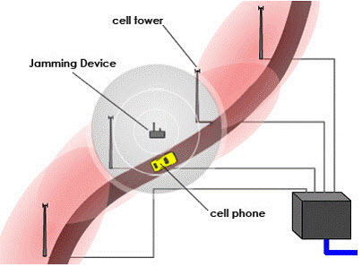

The Mobile phone jammer devices transmit the similar radio frequency which is greater power than the cell phone. The communication between the cell phone and the base station of the phone tower is called as a denial of service attack.

This causes the obstruction with the communication of cell phones and towers to make the cell phones not viable and there is no network visibility. Hence it works in both ways i.e. Cell phone to the tower frequency and the other one is tower to mobile frequency

**4. CONCLUSION**

* The MOBILE PHONE JAMMER was built and implemented.

* The system is targeted at safe guarding valuable items
* The prototype developed can be anywhere in a home or office.
* The preliminary test results are promising.

**5. REFERENCES**

https://www.elprocus.com/

<https://www.google.co.in/imghp?hl=en&tab=wi&authuser=0>

<https://www.electronicshub.org/electronics-tutorials/>